6 AXIS Industrial Robot Mitsubishi Electric (RV-8CRL-D)
A vertical multi-joint robot (8 kg payload, 931 mm reach) with a CR800 D controller and an R32TB teach pendant, equipped with dual/three-jaw grippers.
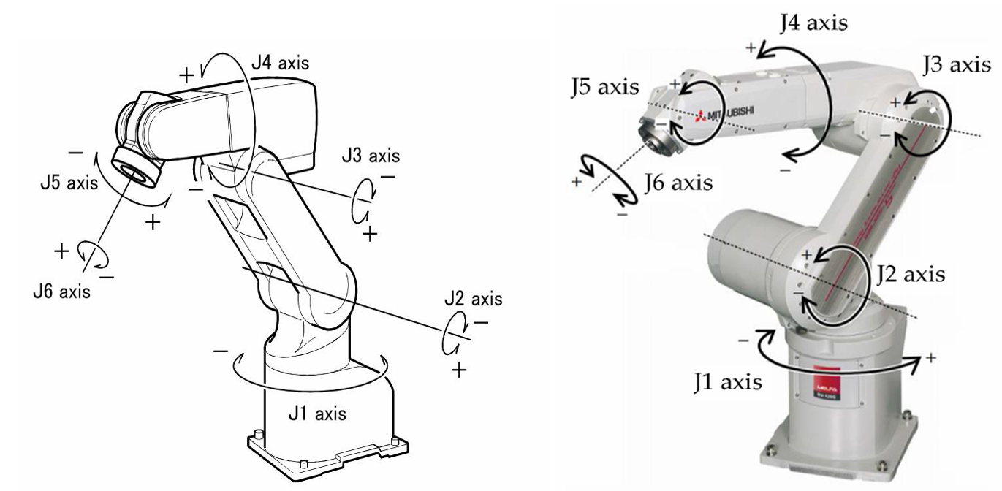
Figure 1. Mitsubishi 6-Axis Industrial Robot Joint Diagram

Specifications:
- Industrial Robot: Mitsubishi Electric RV-8CRL
- Robot Type: Vertical articulated robot
- Degrees of Freedom: 6 axes
- Drive System: AC servo motor
- Position Detection: Absolute encoder
- Maximum Payload Capacity: 8 kg
- Robot End of Arm Tooling (EOAT): As Per Application (Dual two-Jaw and Three-Jaw gripper)
- Controls Panel: FX-5U PLC Control Panel & HMI Operator Panel
- Software: Robot Simulation Software for 01 User

Applications:
- Pick & Place
- Machine Loading & Unloading
- Palatizing,
- Conveyor Tracking, Conveyor Logics, Conveyor Pick & Place
- Robot Path Teaching Drawing
- Practical Board for glueing path, Circular path programming, SPLINE Programming
- Robot TCP Calculation, HMI screen developing for controlling Robot operations, PLC master logic programming, Robot vs human Door & Emergency safety Interlock system. Dual EOAT for the loading and unloading process.

AI-Based 6-Axis Mitsubishi Collaborative Robot (Cobot)
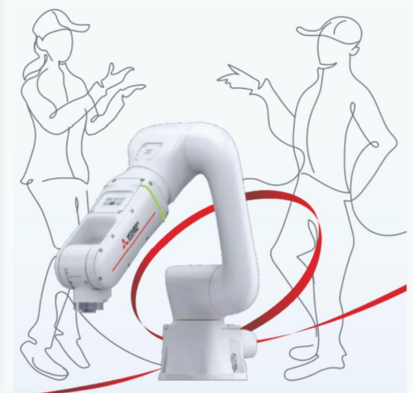
Configuration:
- 6-Axis AI-enabled Collaborative Robot
- Payload: 5 kg
- Reach: 900 mm radius
- Position Repeatability: ±0.03 mm
- High-Speed Mode: 1000 mm/s
- Collaborative Modes: 250 mm/s and 50 mm/s
- Includes Controller and Teach Pendant (7 m cable)
Safety & Interface Features:
- Multi-color LED status indicator
- Standard Digital Inputs/Outputs (DIs/DOs) and Safety I/Os
- Ethernet compatibility
- Plug-and-play interface for electric gripper, force sensor, and vision system
- Built-in solenoid valve set for pneumatic gripper actuation
- Integrated air piping and pneumatic tubing

Applications
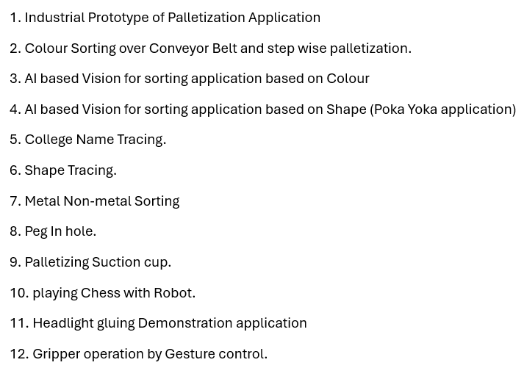
End Effectors
- Electric Sensorized Gripper (1 kg payload)
  - Strain gauges, flexi-force sensor, IR sensor, load cell
  - PLC-controlled
  - Parallel jaw and curvilinear jaw options
- Two-Finger Pneumatic Gripper (500 g payload)
- Magnetic Gripper (500 g payload)
- Vacuum Gripper (500 g payload)

